Thank you for your interest in our Point solution. To better understand your present situation, your environment, and your requirements, we request the following information.

Please complete Sections I-III below with as much information as possible. If there is a question you are unsure of, feel free to skip it and we will work with you to complete it. Please email your completed Survey to your VeriFone Sales Rep and/or VeriFone SE.
- Company Information

Instructions: Please fill in the section below with your company information and billing information. If you are a reseller, this should be your merchant’s information. If you are a merchant, this should be your information.
VeriFone Account Rep | Billing Address
VeriFone Sales Engineer:
Company: | Company:
Address: | Address:
City, State, Zip: | City, State, Zip:
Contact Name: | Contact Name:
Contact Title: | Contact Title
Contact Phone: | Contact Phone:
Contact Fax: | Contact Fax:
Contact Email: | Contact Email:
POS Software Provider: WordStock, Inc.
Reseller Name (if applicable):
Name of Company who will be submitting orders:

- Card Processing
Reference Matrix:
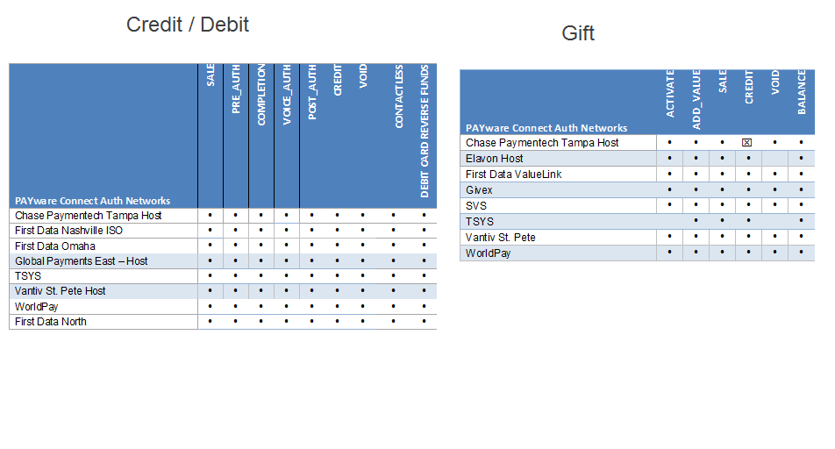

Please indicate which Credit/Debit processor(s) you intend to integrate to or the processors that your customer base currently process to by placing an “X” next to that processor.
Chase Paymentech Tampa Host |  | Global Payments East-Host
First Data Nashville ISO | X | TSYS
First Data North |  | Vantiv St. Pete Host
First Data Omaha |  | WorldPay

Please indicate which Gift processor(s) you intend to integrate to or the processors that your customer base currently process to by placing an “X” next to that processor.
Chase Paymentech Tampa Host |  | SVS
Elavon Host |  | TSYS
First Data ValueLink |  | Vantiv St. Pete Host
Givex |  | WorldPay

Application Configurations

Information for Estate Management Customer ID
Instructions: This section is used to create a login to the VHQ Web Portal. VHQ is the web portal that can be used to remotely update the VeriFone terminal, remotely perform diagnostics on the terminal, or remotely reboot the terminal. Please enter in a login name for the person who you would like to be the administrator for the VHQ web portal, along with their contact information. The administrator can then setup additional users as needed. VHQ is only used for MX model devices today. VeriCentre will be used for Vx model devices, but the information below is still needed.
- If you are a reseller, and will be managing the terminals on behalf of your merchant, fill in your information below.
- If you are a reseller, and the merchant will be managing their own terminals, fill in their information below.
- If you are a merchant, fill in your information below.
Login Name <this is customer primary reporting login, preferably the portion before the @ in an email address>
Key Contact | WordStock CCA Help
Contact Phone | 800-444-7224
Contact Email Address | ccahelp@wordstock.com
Contact Fax Number | N/A

Information for creating customer Estate Management agent configuration file - MX)
Instructions: This section is only required if you are using an MX915 or MX925 device with the Point solution. If default values are desired, please leave this section empty. The values can be modified after the terminal has been installed at the location, if so desired. This section is not required if you are using a VX terminal.
Name | Default | Type | Description | Range | Customer input
MaintenanceStart | 2200 | Integer | Maintenance window start time in the following format: HHMM  Where  HH = 00 – 23  MM = 00 – 59 | 0000 – 2359 | 02:02:00 AM
MaintenanceEnd | 0600 | Integer | Maintenance window end time in the following format: HHMM  Where  HH = 00 – 23  MM = 00 – 59 | 0000 – 2359 | 04:30:00 AM
MaintenanceDays | “*” | String | Maintenance Days for the device. Concatenate the following strings together or use * for all days:  Su – Sunday  M – Monday  Tu – Tuesday  W – Wednesday  Th – Thursday  F – Friday  Sa – Saturday  So for example, Maintenance days on Monday, Tuesday, Thursday and Friday would set this value to “MtuThF” | N/A | *
CustomerId | “VHQdefault” | String | The Customer ID assigned to the customer | N/A | WstckInc0001
***Media files will need to be created.

Information for creating Customer XML file
Instructions: The settings below will determine what features/prompts are turned on or off on the terminal.
Device Configuration Options – Please indicate Y or N
Signature Capture (MX Only) | The terminal will prompt for signature on a credit card transaction. | Y
Split Tender | The terminal will ask the customer if they would like to put the total amount of the transaction on the card they were about to swipe. If they say no, it will ask for the dollar amount they would like to charge. | Y
Counter Tip | The terminal will prompt the customer to enter a tip amount on the device that is immediately added to the total, rather than having to send it with a separate transaction. | N
Loyalty Capture | The terminal will prompt the customer for their phone number at outset of the transaction | N
Email Capture | The terminal will prompt for email at the outset of the transaction | N
Partial Auth | If enabled, a transaction for an amount more than the balance of the card will be accepted and the remaining balance due will be returned to the POS. If not enabled, it will simply decline that transaction. | Y
Credit | Enables this type of transaction prompt on the transaction type selection screen. | Y
Debit | Enables this type of transaction prompt on the transaction type selection screen. | Y
Cashback (only applicable if debit = Y) | The terminal will prompt for cash back on a PIN debit transaction. | N
Gift | Enables this type of transaction prompt on the transaction type selection screen. | N
Google Wallet | Enables this type of transaction prompt on the transaction type selection screen. | Y
ISIS wallet | Enables this type of transaction prompt on the transaction type selection screen. | N
Cash | Enables this type of transaction prompt on the transaction type selection screen. | N
SAF Enabled | Enables local authorization and transaction storage on the terminal if network connectivity is lost. | Y
Transaction Floor Limit (only applicable if SAF Enabled =Y) | The maximum dollar amount of a transaction that can be stored on the device if network connectivity is lost. | 1000
Total Floor Limit (only applicable if SAF Enabled =Y) | The total dollar sum of transactions that the terminal can store. | 5000

If Debit = Y, please indicate the debit key or KSN that should be injected into the terminal:
Debit Key Part Number or KSN

Static IP Configuration Note to Client:

Each device will not be pre-configured for static IP in deployment. It will be required for the device to be configured for specific IP once the device arrives at the site. Please supply the IP information along with instruction to each site being installed.

VeriFone Use Only
VeriFone Billing Dept.
Who will VeriFone invoice?  (ISV/Reseller or Merchant Corp) |  | Bill To Oracle ID
How will Client be invoiced?  (Indicate Terms or ACH) |  | Bill To Amdocs ID
Amdocs Contract ID | POINT NA | Amdocs Schedule ID
VeriFone SIM/CSPM
Implementation Lead |  | PWC Agent ID
Customer Advocate |  | API Name
VeriFone Systems Group
VHQ Company Name  The Company ID is a VeriFone created unique identifier for a Customer |  |  | POINTNA-(company)
VeriCentre CLUSTER Name
Logins Created: VeriFone (HD/SIM/SE)
(Note: VeriFone SE will be Customer Admin Login)

